# Physics Lab Activity: Measuring Your Reaction Time

**Materials:** 1-meter stick or ruler

**Introduction:** Yourreaction time affects your performance in many everyday activities – from driving a car to playing sports to catching something that you drop. Reaction time is the amount of time between an event and your response to it. Work with one other person during this lab, but turn in separate papers.

**Procedure:**

**1.** One person in the group will hold a meter stick vertically between the thumb and index finger of the other person’s open hand. The meter stick should be held so that the zero mark is between your fingers horizontally, and level with the edge of your fingers vertically with the 1 cm mark is above.

**2.** The person catching the meter stick should not be touching the meter stick and their catching hand should not be moving in any way. The thumb and index finger should be separated by at least 5 cm of open space. Lay your arm on a table to steady your hand.

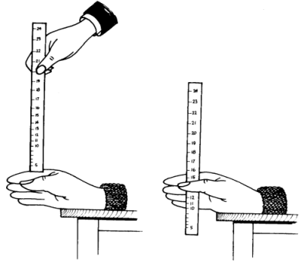**3.** Without warning (but while the catcher is watching!) release the meter stick, so that it falls between the thumb and finger of the person catching the meter stick.

**4.** The person catching should catch the meter stick as quickly as possible.

**5.** Record the distance the meter stick has fallen through the catcher’s fingers. Record to the nearest 0.5 cm instead of 0.01 cm because of the curved nature of human skin that depends on grip pressure, blurring the edge.

**6.** Perform at least 10 trials. Remember to convert centimeters to meters (1 m = 100 cm). So, divide your measurements by 100 to get meters (m).

**7.** Switch roles and record data for the other person’s reaction time.

**Analysis:** 1) Find the average for your catch distance. (Each partner works with their own personal data)

2) Find the standard deviation for your catch distance.

3) Use the kinematic freefall equations to solve for your reaction time.

4) Using the standard deviation of catch distances, propagate your error through the kinematics equation to determine the uncertainty in your reaction time. Let the uncertainty in gravity (-9.81 m/s2 ) be the default 0.01 m/s2.

# Measuring Your Reaction Time Name: ___________________________________

**Partner: _______________________________ Score: _____ / 15**

**Data: Analysis: (Show all work.)**

|  |  |  |
| --- | --- | --- |
| **Trial** | **Catch distance**  **(0.5 cm)** | 1. **Average catch distance: ______________** |
| **1** |  |  |
| **2** |  | 1. **Standard deviation of catch distance: ______________** |
| **3** |  |  |
| **4** |  |  |
| **5** |  |  |
| **6** |  |  |
| **7** |  |  |
| **8** |  | 1. **Calculation of reaction time _______________** |
| **9** |  |  |
| **10** |  |  |
| **Qual. Obs** |  | 1. **Uncertainty in your reaction time: ________________** |

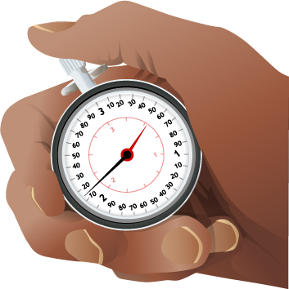**Questions:** (Each person should answer the questions for their own reaction time data. Be very descriptive and support with data/evidence when possible.)

1. What kinds of factors affect your reaction time?
2. Name at least 2 possible sources of errors you might have introduced or made during the experiment.
3. Whose reaction time was faster, you or your partners? Try to explain why.
4. Alcohol can slow your reaction time by as much as thirty percent. Drugs can slow your reaction time by as much as fifty percent. Tests show talking on a cell-phone while driving can slow your reaction time by as much as twenty percent. Multiply the percent (ex. 0.30, 0.50, and 0.20) by your reaction time and then add the number you get from this multiplication to your reaction time. These are your reaction times on alcohol, drugs, and on a cell phone. Do these results surprise you? How might these slowed reaction times affect your performance of daily activities?

Alcohol: ___________ Drugs: ____________ Cell phone: ___________________

